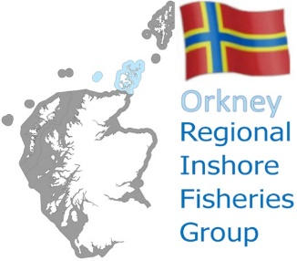

Orkney Regional Inshore Fisheries Group
General Meeting: 7.30pm Tuesday 28 April 2026

AGENDA

- Welcome and Introductions
- Apologies
- Minutes from the meeting held on 03 February 2026
- Matters arising (not on agenda)
- Chair’s Update
- Creel Limitation Scoping Survey (Presentation and discussion)
- Scallop Fisheries (standing agenda item)
- Crab Tagging Project
- Any Other Business
- Next meeting
- Close

Microsoft Teams Meeting Link: Orkney RIFG Meeting | Microsoft Teams | Meet-up-Join

Contact details for Phil

 | 07305 212429 |  | orkneyrifg@gmail.com |  | https://rifg.scot/

